
UNIVERSITY OF GONDAR
COLLAGE OF INFORMATICS
Computer Science Department
Fundamental of database1 project
project Title: "Airlines management system"
NAME ID No
1, YEABSRA ANDARGACHEW...........................................................GUR/01154/16
2, RAHMET HABTAMU.........................................................................GUR/02963/16
3, BIRUK MITIKU...................................................................................GUR/01116/16
4, ARSEMA YIRGA.................................................................................GUR/02128/16
5, ESUYAWKAL FENTAHUN................................................................GUR/01778/16
6, MAHLET BIMR....................................................................................GUR/02783/16
7, FANUEL AYANA.................................................................................GUR/01054/16
8, YIGERMAL KASSIE............................................................................GUR/00991/16
9, ERIMIYAS TOMAS..............................................................................GUR/02749/16
10, KIRUBEL WORKALMAHU...............................................................GUR/01192/16
11, EYERUS SEMUNIGUS.......................................................................GUR/
Instructor: Redet Getachew
Submission Date: March 14,2025


Table of Contents
Chapter One: Introduction-----------------------------------------------------------------------------
1.1 Background ------------------------------------------------------------------------------------------------
1.2 Statement of the Problem --------------------------------------------------------------------
1.3 Objectives --------------------------------------------------------------------------------------------------
1.4 Methodology ---------------------------------------------------------------------------------------------
1.4.1 Data Collection Technique ----------------------------------------------------------------
1.4.2 Database Modeling Approach -------------------------------------------------------------------
1.4.3 Hardware and Software Requirements ----------------------------------------------------------
Chapter Two: Database Design ------------------------------------------------------------------------
2.1 Overview of Database Modeling -----------------------------------------------------------------------
2.2 Business Rules/Requirements ------------------------------------------------------------------------
2.3 Building Blocks of the Database ------------------------------------------------------------------------
2.3.1 Tables and Fields ------------------------------------------------------------------------
2.3.2 Primary and Foreign Keys ------------------------------------------------------------------------
2.3.3 Relationships and Constraints --------------------------------------------------------------------
2.4 ER Diagram ------------------------------------------------------------------------------------------------
2.5 Relational Model: Mapping ER Diagram to Relational Model ------------------------------------
2.6 Normalization ---------------------------------------------------------------------------------------
Chapter Three: Database Implementation---------------------------------------------------------------
3.1 SQL Commands to Develop Your Database ----------------------------------------------------------
3.2 Relational Diagram/Class Diagram -------------------------------------------------------------------
3.3 Class Diagram --------------------------------------------------------------------------------------------
3.4 Explanation and Integration ------------------------------------------------------------------------

Appendices -----------------------------------------------------------------------------------------------------
Appendix A: Additional SQL Scripts and Sample Queries ------------------------------------
Bibliography ---------------------------------------------------------------------------------------------------

Chapter One
Introduction
1.1 Background
The airline industry is a cornerstone of the global economy, connecting cities and countries while facilitating international trade, tourism, and business travel. Over the past few decades, this industry has experienced exponential growth in both passenger volume and operational complexity. As airlines expand their networks and manage increasingly dynamic schedules, the need for efficient, accurate, and scalable systems becomes paramount. Traditional manual methods of handling reservations, flight schedules, passenger records, and related data are not only time-consuming but also prone to human error. This has driven the industry toward automation, with modern database management systems (DBMS) playing a critical role in transforming operational workflows.
Automation in the airline sector addresses several challenges inherent in the manual processing of data. In a rapidly evolving industry, delays or errors in processing flight bookings and managing schedules can result in significant financial losses and deteriorated customer satisfaction. By automating these processes, airlines can ensure real-time data updates, reduce redundancy, and minimize the risk of errors—thereby enhancing both operational efficiency and service quality. The transition to automated systems supports better resource allocation, improved decision-making, and a more reliable management of critical data, all of which are essential for maintaining competitiveness in a global market.
From a technological perspective, this project leverages a relational database management system using Structured Query Language (SQL). SQL offers a powerful and standardized approach to managing large datasets, making it ideal for handling complex queries and ensuring data integrity across multiple interconnected entities. Additionally, the project utilizes Turbo C++ as the development environment for building the application’s user interface and core logic. This combination of SQL for backend data handling and Turbo C++ for front-end application development provides a robust framework that can manage large volumes of data while offering the speed and reliability required by modern airline operations.
In the context of the airline industry, the significance of automating database management extends beyond mere data storage. It is about creating a responsive system that can adapt to rapidly changing conditions, such as sudden schedule alterations, high demand during peak travel seasons, and emergency operational adjustments. An automated Airline Management System not only streamlines day-to-day processes but also enhances the overall customer experience by ensuring that information is accurate, accessible, and updated in real time. As airlines strive to offer seamless travel experiences and competitive service levels, the deployment of such a system is both timely and essential.
Overall, the development of an automated Airline Management System represents a strategic move towards digital transformation in the aviation sector. By integrating advanced database technologies and efficient programming tools, this project aims to provide a comprehensive solution that addresses the operational challenges of modern airlines. The end goal is to deliver a system that not only improves internal processes but also contributes to enhanced passenger satisfaction and overall service excellence.
1.2 Statement of the Problem
Airline operations today are increasingly complex, with a growing need to manage vast amounts of data related to flight schedules, reservations, and passenger records. Currently, many airlines continue to rely on manual or semi-automated processes that are both time-consuming and prone to error. For example, reservation management often involves manual entries or unintegrated digital tools, which can lead to issues like duplicate bookings or lost data. Flight scheduling is similarly hampered by outdated methods, resulting in delays and inaccurate information being communicated to passengers and staff. Furthermore, the manual handling of passenger records makes it difficult to retrieve or update information quickly during emergencies or last-minute changes. These practices not only lead to data redundancy and inconsistencies but also create significant obstacles in sharing critical information across different departments, thereby slowing decision-making and operational responses. As a result, airlines face increased operational costs, reduced customer satisfaction, and a diminished ability to respond swiftly to changing conditions.
1.3 Objectives
General Objective
Develop an automated, efficient database management system for airline operations that streamlines data handling, improves operational efficiency, and enhances overall service quality.
Specific Objectives
- Comprehensive Data Storage and Retrieval: Develop a robust system to store and retrieve detailed information related to flight schedules, reservations, and passenger records.
- Data Integrity and Redundancy Reduction: Implement normalization and integrity constraints to ensure that data is consistent and free of redundancy across the system.
- Optimized Query Performance: Enhance the performance of database queries through indexing and optimization techniques to facilitate quick and efficient access to data.
- Improved Data Sharing: Create interfaces and integration mechanisms that allow seamless sharing of critical data between various departments, such as reservations, operations, and customer service.
- Scalability and Future Expansion: Design the system to be scalable and adaptable, enabling future enhancements and integration with emerging technologies as the airline’s operational needs evolve.
1.4 Methodology
The methodology for developing the Airline Management System is designed to ensure that the project meets the operational needs of modern airlines through systematic data collection, robust database modeling, and careful planning of hardware and software resources.
1.4.1 Data Collection Technique
To create a system that accurately reflects real-world operations, a mixed-method approach was employed. Historical data from existing airline records was analyzed to pinpoint recurring issues in reservations, flight schedules, and passenger management. In addition, industry standards and best practices were reviewed to understand the benchmarks for operational efficiency and data integrity. To further refine the requirements, surveys and interviews were conducted with airline staff and management. These interactions provided valuable insights into the pain points of manual processes and highlighted the need for automation, ensuring that both quantitative data and qualitative feedback informed the project’s scope.
1.4.2 Database Modeling Approach
Given the complexity and volume of data involved in airline operations, a relational database model was selected as the backbone of the system. The choice of a relational model was driven by its proven ability to manage structured data effectively while enforcing data integrity through primary and foreign key constraints. The modeling process began with the development of an Entity-Relationship (ER) diagram. This diagram visually represents the key entities—such as Flights, Passengers, Reservations, and Employees—and the relationships among them. The ER diagram was then translated into a relational schema, where each entity became a table, and the relationships were implemented using foreign keys. This approach also incorporated normalization techniques (up to 3NF or higher if necessary) to reduce data redundancy and eliminate anomalies, ensuring that the database remains efficient and scalable as the volume of data increases.
1.4.3 Hardware and Software Requirements
To support the development and deployment of the Airline Management System, specific hardware and software requirements were identified:
- Server and Database Hardware: A dedicated server or cloud-based virtual machine to host the database. Sufficient storage capacity to handle large volumes of flight records, reservation data, and historical logs. High-performance processors and ample RAM to support real-time query processing and data manipulation.
- Database Management System (DBMS): A robust relational database management system such as MySQL, SQL Server, or PostgreSQL. Tools for backup, recovery, and performance monitoring to ensure data security and system reliability.
- Development Tools: Turbo C++ IDE: Used for developing the application’s user interface and core logic, offering an environment that supports efficient code development and debugging. SQL development tools for writing, testing, and optimizing queries. Version control systems (e.g., Git) to manage source code and facilitate collaborative development among team members.
- Additional Resources: Network infrastructure to enable reliable communication between the application and the database server. Security protocols and software to safeguard data and ensure compliance with industry standards. User interface design tools to create a user-friendly front end that meets the needs of airline staff and administrators.
By integrating these methodologies, the project aims to develop a comprehensive and automated Airline Management System that addresses the challenges of manual data processing while ensuring scalability, reliability, and enhanced performance in managing airline operations.

Chapter Two
Database Design
2.1 Overview of Database Modeling
Database modeling is a critical process in designing an efficient and scalable system for managing airline data. A well-structured database serves as the backbone of the Airline Management System, ensuring that all data ranging from flight schedules to passenger records is stored in an organized, consistent, and easily accessible manner.
Importance of Database Design: Effective database design is essential because it directly impacts data retrieval speed, data integrity, and overall system performance. A robust design minimizes redundancy, ensures data consistency, and supports the dynamic requirements of the airline industry.
Key Concepts:
- Tables: Tables are the primary building blocks of the database. Each table represents an entity (e.g., Flights, Passengers, Reservations) and contains rows (records) and columns (attributes) that define the properties of that entity.
- Relationships: Relationships define how tables are connected to one another. For instance, the relationship between the Flights and Reservations tables can be modeled as one-to-many, where one flight can have multiple reservations. Establishing clear relationships is crucial for maintaining data consistency across the system.
- Constraints: Constraints are rules applied to the database to enforce data integrity. Examples include primary keys (ensuring each record is unique), foreign keys (maintaining valid references between tables), and check constraints (enforcing valid data values such as correct reservation dates).

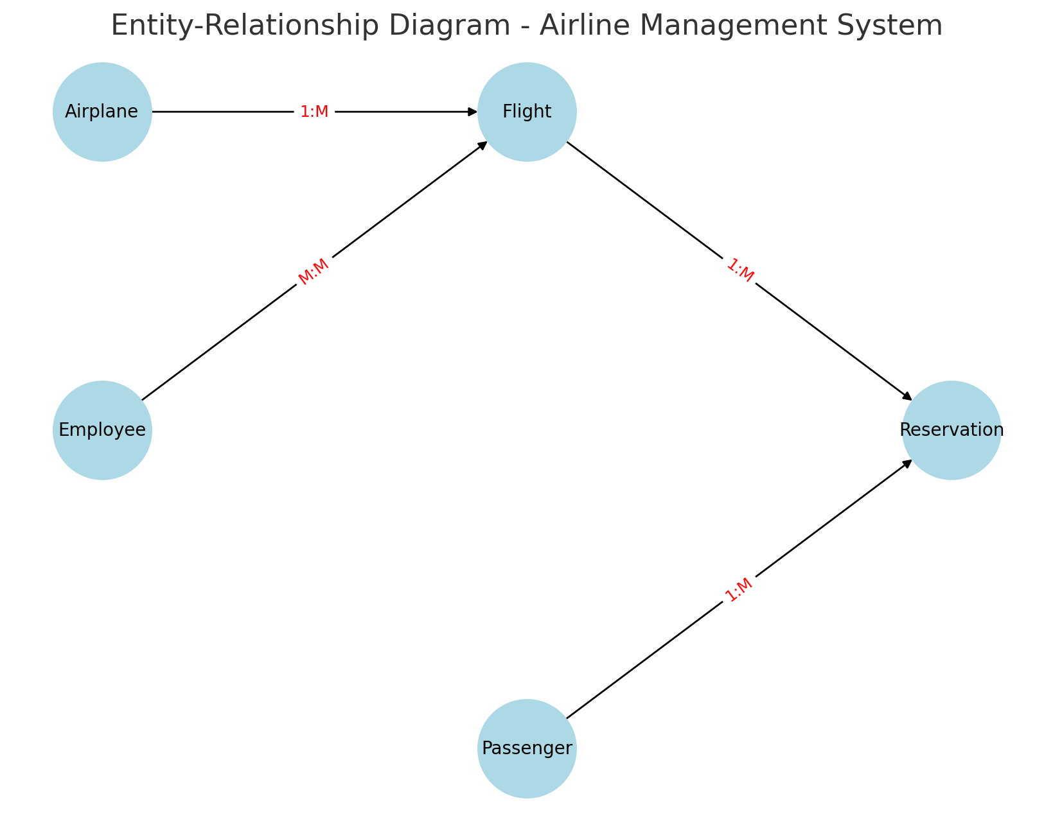
2.2 Business Rules/Requirements
The success of the Airline Management System depends on the strict enforcement of business rules and data integrity constraints. These rules ensure that the system operates reliably and accurately reflects real-world airline operations.
Specific Business Rules:
- Uniqueness of Flight Numbers: Every flight must have a unique identifier to prevent confusion and enable efficient scheduling and reservation management.
- Valid Reservation Dates: Reservation dates must fall within a valid range relative to flight schedules. The system should reject reservations with dates that do not correspond to scheduled flights or that are set in the past.
- Passenger Record Integrity: Passenger information must be consistently recorded and updated. Rules such as valid contact numbers and mandatory fields (name, address, etc.) ensure complete records.
- Reservation Limits: The system should enforce seat capacity limits for each flight. This includes preventing overbooking by checking the current reservation count against the aircraft's capacity.
- Data Consistency and Referential Integrity: Foreign key constraints must ensure that relationships between tables (e.g., Reservations referencing valid Flight IDs and Passenger IDs) are maintained. Any deletion or update in primary tables should cascade appropriately or be restricted to avoid orphan records.
Data Integrity Constraints and Dependencies:
- Primary Keys and Unique Constraints: These are used to uniquely identify each record in a table, such as Flight IDs, Passenger IDs, and Reservation IDs.
- Foreign Keys: They link related records across tables, ensuring that a reservation always corresponds to an existing flight and a registered passenger.
- Check Constraints: Enforce rules such as valid date ranges, permissible status values for reservations (e.g., confirmed, cancelled), and other domain-specific conditions.
- Triggers/Stored Procedures : Consider implementing triggers to automatically update seat availability or notify users of changes, further enforcing business rules.

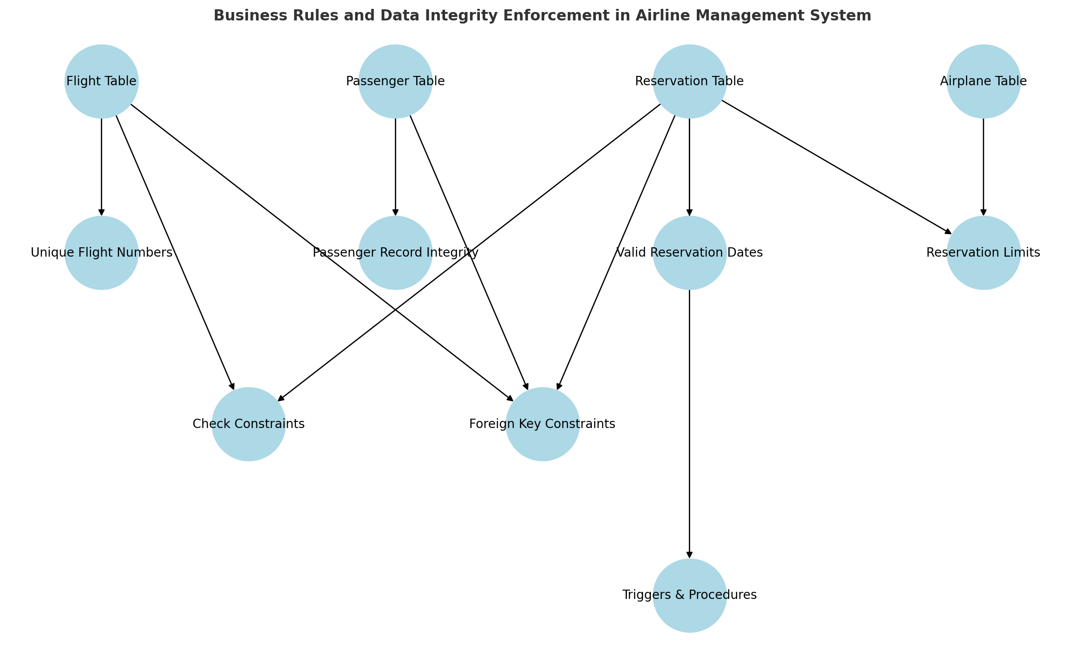
Diagram 1: Business Rules/Requirements
2.3 Building Blocks of the Database
A robust Airline Management System relies on well-designed database building blocks. These components form the foundation that supports data integrity, scalability, and efficient data retrieval. This section describes the essential tables, key attributes, primary and foreign keys, as well as the relationships and constraints that maintain the consistency of the system.
2.3.1 Tables and Fields
The database for the Airline Management System comprises several essential tables. Each table represents an entity within the airline operations, and the fields within these tables capture specific details about that entity. Below is an example list of essential tables along with key attributes for each:
Flight Table
Key Attributes:
- Flight_ID (Primary Key): A unique identifier for each flight.
- Flight_Number: The flight number as provided by the airline.
- Departure_Time and Arrival_Time: Scheduled times for takeoff and landing.
- Source and Destination: Airport codes or names indicating the starting point and destination.
- Airplane_ID: References the aircraft assigned to the flight.
Passenger Table
Key Attributes:
- Passenger_ID (Primary Key): A unique identifier for each passenger.
- Name: The full name of the passenger.
- Address: Contact or residential information.
- Contact_Number: Phone number for communication.
- Email: Email address for notifications and record-keeping.
Reservation Table
Key Attributes:
- Reservation_ID (Primary Key): Unique reservation number.
- Flight_ID (Foreign Key): Links to the Flight table.
- Passenger_ID (Foreign Key): Links to the Passenger table.
- Reservation_Date: Date when the reservation was made.
- Seat_Number: Assigned seat for the passenger.
- Status: Indicates if the reservation is confirmed, pending, or cancelled.
Employee Table
Key Attributes:
- Employee_ID (Primary Key): Unique identifier for airline employees.
- Name: Employee’s full name.
- Designation: Role or position in the airline (e.g., reservation clerk, pilot, etc.).
- Contact_Details: Phone number and email for internal communications.
Airplane Table
Key Attributes:
- Airplane_ID (Primary Key): Unique identifier for each aircraft.
- Model: The type or model of the airplane.
- Capacity: Number of seats available on the aircraft.
- Airline: The operating airline for the aircraft.
2.3.2 Primary and Foreign Keys
Primary Keys:
Primary keys are unique identifiers for each record in a table. They ensure that no two records can have the same key, thus maintaining uniqueness and allowing for efficient indexing. For instance, Flight_ID in the Flight table uniquely identifies each flight, while Passenger_ID in the Passenger table ensures each passenger record is distinct.
Foreign Keys:
Foreign keys create links between tables, enforcing referential integrity. They ensure that a record in one table corresponds to a valid record in another table. For example:
- In the Reservation table, Flight_ID is a foreign key that refers to the Flight_ID in the Flight table.
- Similarly, Passenger_ID in the Reservation table is a foreign key that refers to the Passenger_ID in the Passenger table.
These keys ensure that every reservation is associated with an existing flight and a registered passenger, thus maintaining data consistency across the database.
2.3.3 Relationships and Constraints
Relationships:
- One-to-Many Relationships: A single flight can have multiple reservations. This is represented by the relationship between the Flight table (one flight) and the Reservation table (many reservations). An employee, such as a booking clerk, might handle multiple reservations, establishing a one-to-many relationship between Employee and Reservation if required by the system design.
- Many-to-Many Relationships: In some cases, the relationship between passengers and flights may be many-to-many if a passenger can book multiple flights and each flight can have multiple passengers. This is typically managed by introducing a linking table (in our example, the Reservation table serves as this intermediary).
Constraints:
- Uniqueness Constraints: Ensure that attributes like flight numbers, reservation IDs, and passenger IDs remain unique.
- Check Constraints: Enforce valid data entries, such as ensuring that the Reservation_Date falls within acceptable bounds relative to flight schedules, or that Seat_Number values are within the seating capacity of the corresponding airplane.
- Referential Integrity Constraints: Maintain the consistency of foreign key relationships. For example, if a flight is canceled, the system might use cascading rules to update or restrict deletion in the Reservation table to prevent orphaned records.
- Additional Constraints: Constraints such as ensuring that the Departure_Time is earlier than the Arrival_Time for a flight, or that employee contact details follow a specified format, are crucial for data accuracy.
2.4 ER Diagram
The Entity-Relationship (ER) Diagram for the Airline Management System visually represents the key entities, their attributes, and the relationships between them. This diagram is essential for understanding the overall data structure before implementation.
Key Entities and Their Attributes:
Flight
Attributes:
- Flight_ID (Primary Key)
- Flight_Number
- Departure_Time
- Arrival_Time
- Source
- Destination
- Airplane_ID (Foreign Key)
Passenger
Attributes:
- Passenger_ID (Primary Key)
- Name
- Address
- Contact_Number
- Email
Reservation
Attributes:
- Reservation_ID (Primary Key)
- Flight_ID (Foreign Key)
- Passenger_ID (Foreign Key)
- Reservation_Date
- Seat_Number
- Status
Employee
Attributes:
- Employee_ID (Primary Key)
- Name
- Designation
- Contact_Details
Airplane
Attributes:
- Airplane_ID (Primary Key)
- Model
- Capacity
- Airline
Relationships:
- Flight–Reservation: One flight can have multiple reservations (one-to-many).
- Passenger–Reservation: One passenger can book multiple flights; each reservation links one passenger to one flight (many-to-many managed via the Reservation table).
- Airplane–Flight: One airplane can serve multiple flights (one-to-many).
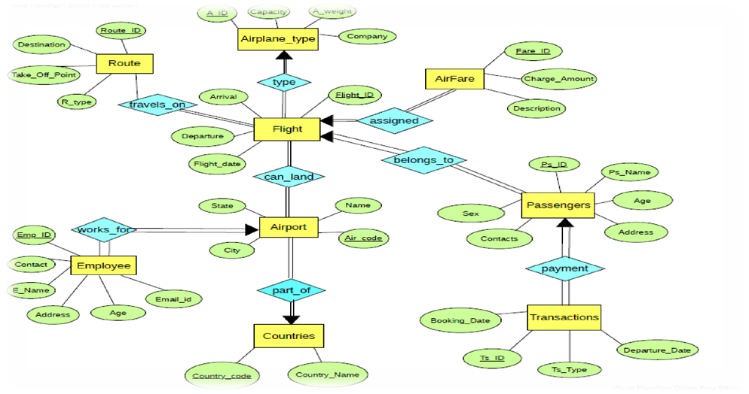

2.5 Relational Model: Mapping ER Diagram to Relational Model
Transforming the ER diagram into a relational model involves creating a table for each entity and using primary and foreign keys to enforce the relationships.
Transformation Process:
- Entity to Table Conversion: Each entity (e.g., Flight, Passenger, Reservation, Employee, Airplane) becomes a table. The entity’s attributes become the table’s columns.
- Primary Keys: Each table uses a primary key (e.g., Flight_ID, Passenger_ID) to uniquely identify its records.
- Foreign Keys: Relationships between entities are maintained using foreign keys. For example, the Reservation table includes:
  - Flight_ID referencing the Flight table, and
  - Passenger_ID referencing the Passenger table.
- Handlinng Relationships:
- One-to-Many Relationships: A single flight (in the Flight table) is linked to many reservations (in the Reservation table) by including the Flight_ID as a foreign key in the Reservation table.
- Many-to-Many Relationships: Managed by the Reservation table, which acts as an associative table between the Passenger and Flight entities
Table Structures:
Flight Table:
CREATE TABLE Flight (
Flight_ID INT PRIMARY KEY,
Flight_Number VARCHAR(10),
Departure_Time DATETIME,
Arrival_Time DATETIME,
Source VARCHAR(50),
Destination VARCHAR(50),
Airplane_ID INT,
FOREIGN KEY (Airplane_ID) REFERENCES Airplane(Airplane_ID)
);
Passenger Table:
CREATE TABLE Passenger (
Passenger_ID INT PRIMARY KEY,
Name VARCHAR(100),
Address VARCHAR(150),
Contact_Number VARCHAR(15),
Email VARCHAR(100)
);
Reservation Table:
CREATE TABLE Reservation (
Reservation_ID INT PRIMARY KEY,
Flight_ID INT,
Passenger_ID INT,
Reservation_Date DATE,
Seat_Number VARCHAR(10),
Status VARCHAR(20),
FOREIGN KEY (Flight_ID) REFERENCES Flight(Flight_ID),
FOREIGN KEY (Passenger_ID) REFERENCES Passenger(Passenger_ID)
);
Employee Table:
CREATE TABLE Employee (
Employee_ID INT PRIMARY KEY,
Name VARCHAR(100),
Designation VARCHAR(50),
Contact_Details VARCHAR(100)
);
Airplane Table:
CREATE TABLE Airplane (
Airplane_ID INT PRIMARY KEY,
Model VARCHAR(50),
Capacity INT,
Airline VARCHAR(50)
);
2.6 Normalization
Normalization is the process of organizing the database structure to minimize redundancy and dependency by dividing large tables into smaller, interrelated tables. This process helps in maintaining data integrity and ensuring that the database remains efficient and free from update, insert, and delete anomalies.
This is our unnormalized table

Flight_ID | Passenger_ID | Passenger_Name | Reservation_Date | Seat_Number
101 | 1 | Redet Getachew | 2023-10-01 | 1A
101 | 2 | Kitaw Ejigu | 2023-10-01 | 1B
102 | 1 | Selemon Kassa | 2023-10-02 | 2A

First Normal Form (1NF):
The first step in normalization is to ensure that the table meets the criteria for 1NF. This involves:
- Atomicity: Every column must contain only atomic (indivisible) values. For example, a field that stores a passenger’s full name should be separated into first name and last name if needed.
- Elimination of Repeating Groups: Each record must be unique, and there should be no repeating groups or arrays. In the context of the Airline Management System, rather than having multiple columns for seat numbers within one record, each reservation should be stored in its own row.
Flight_ID | Passenger_ID | Passenger_Name | Reservation_Date | Seat_Number
101 | 1 | Redet Getachew | 2023-10-01 | 1A
101 | 2 | Kitaw Ejigu | 2023-10-01 | 1B
102 | 1 | Selemon Kassa | 2023-10-02 | 2A

Second Normal Form (2NF):
Once 1NF is achieved, the next step is to reach 2NF, which applies to tables with composite primary keys. A table is in 2NF if:
- It is already in 1NF.
- All non-key attributes are fully functionally dependent on the entire primary key, meaning there should be no partial dependency. For example, consider a table that stores reservation details with a composite key consisting of Flight_ID and Passenger_ID. Any attribute like Reservation_Date must depend on both Flight_ID and Passenger_ID rather than just one part of the key.

- Create a separate table for Passengers to eliminate partial dependencies:
Passenger Table:
Passenger_ID | Passenger_Name
1 | Redet Getachew
2 | Kitaw Ejigu

Reservation Table:

Flight_ID | Passenger_ID | Reservation_Date | Seat_Number
101 | 1 | 2023-10-01 | 1A
101 | 2 | 2023-10-01 | 1B
102 | 1 | 2023-10-02 | 2A

Third Normal Form (3NF):
A table is in 3NF when:
- It is in 2NF.
- There are no transitive dependencies, meaning non-key attributes do not depend on other non-key attributes. For instance, if the Reservation table included a field like Passenger_Address, which is already maintained in the Passenger table, it should be removed from the Reservation table. This separation prevents anomalies where updates to a passenger’s address must be performed in multiple places.

Passenger_ID | Passenger_Name | Passenger_Address
1 | Redet Getachew | 123 Elm St
2 | Kitaw Ejigu | 456 Oak St

Passenger_ID | Passenger_Name | Passenger_Address
1 | Redet Getachew | 123 Elm St
2 | Kitaw Ejigu | 456 Oak St

Reservation Table: Passenger Table:

Flight_ID | Passenger_ID | Reservation_Date | Seat_Number
101 | 1 | 2023-10-01 | 1A
101 | 2 | 2023-10-01 | 1B
102 | 1 | 2023-10-02 | 2A

Boyce-Codd Normal Form (BCNF)
To achieve BCNF, we ensure that every determinant is a candidate key. If any non-key attribute determines another non-key attribute, we need to separate them. In our current structure, there are no such issues, so it remains:

Final Passenger Table:

Passenger_ID | Passenger_Name | Passenger_Address
1 | Redet Getachew | 123 Elm St
2 | Kitaw Ejigu | 456 Oak St
Final Reservation Table:

Flight_ID | Passenger_ID | Reservation_Date | Seat_Number
101 | 1 | 2023-10-01 | 1A
101 | 2 | 2023-10-01 | 1B
102 | 1 | 2023-10-02 | 2A

Benefits of Normalization:
- Reduction of Redundancy: By breaking down tables into smaller, related tables, normalization eliminates redundant data. This minimizes storage requirements and ensures that data is stored only once. For example, storing passenger information in a separate Passenger table instead of duplicating it in every reservation record reduces repetition and simplifies updates.
- Prevention of Data Anomalies: Normalization protects the database against several types of anomalies:
- Update Anomalies: Changes made in one place (e.g., updating a passenger’s contact information) do not require multiple modifications across redundant records.
- Insert Anomalies: The structured separation of data allows for adding new records without requiring unnecessary data from other fields. For instance, a new flight can be added without immediately requiring reservation details.
- Delete Anomalies: Removing a record from one table (such as a reservation) will not inadvertently remove critical information (like passenger details), because the data is stored in separate, related tables.
Higher Normal Forms
In some cases, further normalization beyond 3NF (such as Boyce-Codd Normal Form, BCNF) might be necessary, especially when dealing with complex dependencies. However, for many applications, including the Airline Management System, 3NF provides an optimal balance between data integrity and system performance.

Conclusion
Through the normalization process, the Airline Management System’s database is designed to be robust, scalable, and easy to maintain. By ensuring that each table contains only related data, and by enforcing strict dependencies between data elements, normalization not only enhances data integrity but also improves query performance and overall system reliability.

Chapter Three
Database Implementation
3. 1 SQL Commands
Table Creation
Below are the SQL commands to create the main tables for the Airline Management System. Each table is defined with primary keys and appropriate foreign key constraints to maintain referential integrity.
-- Create Airplane Table
CREATE TABLE Airplane (
Airplane_ID INT PRIMARY KEY,
Model VARCHAR(50) NOT NULL,
Capacity INT NOT NULL,
Airline VARCHAR(50) NOT NULL
);
-- Create Flight Table
CREATE TABLE Flight (
Flight_ID INT PRIMARY KEY,
Flight_Number VARCHAR(10) UNIQUE NOT NULL,
Departure_Time DATETIME NOT NULL,
Arrival_Time DATETIME NOT NULL,
Source VARCHAR(50) NOT NULL,
Destination VARCHAR(50) NOT NULL,
Airplane_ID INT NOT NULL,
CONSTRAINT FK_Flight_Airplane FOREIGN KEY (Airplane_ID)
REFERENCES Airplane(Airplane_ID)
);
-- Create Passenger Table
CREATE TABLE Passenger (
Passenger_ID INT PRIMARY KEY,
Name VARCHAR(100) NOT NULL,
Address VARCHAR(150),
Contact_Number VARCHAR(15),
Email VARCHAR(100) UNIQUE
);
-- Create Reservation Table
CREATE TABLE Reservation (
Reservation_ID INT PRIMARY KEY,
Flight_ID INT NOT NULL,
Passenger_ID INT NOT NULL,
Reservation_Date DATE NOT NULL,
Seat_Number VARCHAR(10) NOT NULL,
Status VARCHAR(20) NOT NULL,
CONSTRAINT FK_Reservation_Flight FOREIGN KEY (Flight_ID)
REFERENCES Flight(Flight_ID),
CONSTRAINT FK_Reservation_Passenger FOREIGN KEY (Passenger_ID)
REFERENCES Passenger(Passenger_ID)
);
-- Create Employee Table
CREATE TABLE Employee (
Employee_ID INT PRIMARY KEY,
Name VARCHAR(100) NOT NULL,
Designation VARCHAR(50),
Contact_Details VARCHAR(100)
);
Inserting Sample Data
The following SQL commands insert sample data into the key tables. These examples illustrate how the tables can be populated with initial records.
-- Inserting sample data into the Airplane Table
INSERT INTO Airplane (Airplane_ID, Model, Capacity, Airline) VALUES
(1, 'Boeing 737', 150, 'Airline A'),
(2, 'Airbus A320', 180, 'Airline B'),
(3, 'Boeing 777', 300, 'Airline C');
-- Inserting sample data into the Flight Table
INSERT INTO Flight (Flight_ID, Flight_Number, Departure_Time, Arrival_Time, Source, Destination, Airplane_ID) VALUES
(101, 'AA101', '2022-12-01 08:00:00', '2022-12-01 10:30:00', 'New York', 'Chicago', 1),
(102, 'BB202', '2022-12-02 09:15:00', '2022-12-02 12:00:00', 'Los Angeles', 'New York', 2),
(103, 'CC303', '2022-12-03 14:00:00', '2022-12-03 18:00:00', 'Chicago', 'Miami', 3);
-- Inserting sample data into the Passenger Table
INSERT INTO Passenger (Passenger_ID, Name, Address, Contact_Number, Email) VALUES
(1, 'Rahmet Hab', '123 Main St, New York', '123-456-7890', 'reem@gmail.com'),
(2, 'Yeabsra And', '456 Park Ave, Los Angeles', '987-654-3210', 'yeab@gmail.com'),
(3, 'Arsema Yir', '789 Broadway, Chicago', '555-123-4567', 'arsu@gmail.com');
-- Inserting sample data into the Reservation Table
INSERT INTO Reservation (Reservation_ID, Flight_ID, Passenger_ID, Reservation_Date, Seat_Number, Status) VALUES
(1001, 101, 1, '2022-11-25', '12A', 'Confirmed'),
(1002, 102, 2, '2022-11-26', '15B', 'Confirmed'),
(1003, 103, 3, '2022-11-27', '8C', 'Pending');
-- Inserting sample data into the Employee Table
INSERT INTO Employee (Employee_ID, Name, Designation, Contact_Details) VALUES
(1, 'Biruk Mitiku', 'Reservation Manager', 'bura.mit@airline.com'),
(2, 'Esuyawukal Abebe', 'Flight Coordinator', 'esu.abe@airline.com');
Constraints and Indexes
To enhance performance and maintain data integrity, additional constraints and indexes can be implemented. The following commands illustrate how to add unique constraints, check constraints, and indexes.
-- Adding a UNIQUE constraint on Flight_Number (already included in the Flight table creation)
-- ALTER TABLE Flight ADD CONSTRAINT uq_flight_number UNIQUE (Flight_Number);
-- Creating an index on the Departure_Time column in the Flight table to improve query performance
CREATE INDEX idx_flight_departure ON Flight (Departure_Time);
-- Creating an index on the Reservation_Date column in the Reservation table
CREATE INDEX idx_reservation_date ON Reservation (Reservation_Date);
-- Adding a CHECK constraint to ensure the Status in the Reservation table is one of the allowed values
ALTER TABLE Reservation
ADD CONSTRAINT chk_reservation_status CHECK (Status IN ('Confirmed', 'Pending', 'Cancelled'));
-- Adding a CHECK constraint to ensure that Seat_Number follows a specific format
-- (Note: The exact syntax for pattern matching may vary depending on the SQL dialect)
ALTER TABLE Reservation
ADD CONSTRAINT chk_seat_format CHECK (Seat_Number LIKE '[0-9][0-9]?[A-Z]');

CREATE VIEW FlightView AS
SELECT
f.Flight_ID,
f.Flight_Number,
f.Departure_Time,
f.Arrival_Time,
f.Source,
f.Destination,
a.Model AS Airplane_Model,
a.Capacity AS Airplane_Capacity,
a.Airline AS Airplane_Airline
FROM
Flight f
JOIN
Airplane a ON f.Airplane_ID = a.Airplane_ID;

3.2 Relational Diagram/Class Diagram
Relational Diagram
The relational diagram provides a visual representation of the tables in the Airline Management System and their relationships. This diagram is essential to understand how data is organized and how the tables interact. The key components of the relational diagram include:
Entities (Tables): Each table is represented as a rectangle with its name and key attributes listed.
- Airplane: Contains attributes such as Airplane_ID (Primary Key), Model, Capacity, and Airline.
- Flight: Includes Flight_ID (Primary Key), Flight_Number, Departure_Time, Arrival_Time, Source, Destination, and Airplane_ID (Foreign Key).
- Passenger: Lists Passenger_ID (Primary Key), Name, Address, Contact_Number, and Email.
- Reservation: Contains Reservation_ID (Primary Key), Flight_ID and Passenger_ID (Foreign Keys), Reservation_Date, Seat_Number, and Status.
- Employee: Lists Employee_ID (Primary Key), Name, Designation, and Contact_Details.
Relationships:
Lines between the rectangles represent the relationships:
A one-to-many relationship exists between Airplane and Flight (one airplane can serve multiple flights). Flight and Reservation are linked in a one-to-many fashion (one flight may have many reservations). Passenger and Reservation are also connected in a one-to-many (or effectively many-to-many if viewed from the overall system perspective) manner, where one passenger may have multiple reservations.
Cardinality and Constraints: The diagram should indicate cardinality (for example, “1” near the Airplane table and “N” near the Flight table) and note that the foreign keys enforce referential integrity. Additional symbols or annotations can denote any check constraints or unique constraints applied to specific fields (such as ensuring that Flight_Number is unique).
3.3 Class Diagram (Optional, if using OOP Concepts)
If your project incorporates object-oriented programming—such as using Turbo C++ for application logic—a class diagram can be a valuable addition. The class diagram outlines how classes (which often mirror the database tables) are structured and interact.
Key Elements of the Class Diagram:
Classes Corresponding to Database Tables:
For each table in the relational model, there might be a corresponding class in your application.
Airplane Class:
- Attributes: Airplane_ID, Model, Capacity, Airline.
- Methods: Methods to retrieve or update airplane details.
Flight Class:
- Attributes: Flight_ID, Flight_Number, Departure_Time, Arrival_Time, Source, Destination, Airplane_ID.
- Methods: Methods to schedule flights, update timings, or check flight status.
Passenger Class:
- Attributes: Passenger_ID, Name, Address, Contact_Number, Email.
- Methods: Methods to register passengers, update details, or manage contact information.
Reservation Class:
- Attributes: Reservation_ID, Flight_ID, Passenger_ID, Reservation_Date, Seat_Number, Status.
- Methods: Methods to create, modify, or cancel reservations.
Employee Class:
- Attributes: Employee_ID, Name, Designation, Contact_Details.
- Methods: Methods for managing employee records and related operations.
Relationships between Classes:
Just as in the relational diagram, the class diagram should illustrate the relationships:
A Flight object may contain a reference to an Airplane object (aggregation or composition).
A Reservation object typically maintains associations with both Flight and Passenger objects.
Association, Aggregation, and Inheritance
You can also indicate if any classes inherit from a common base class (for example, a Person class from which Passenger and Employee might derive common attributes) or if there are any other associations that enhance code reuse and organization.
3.4 Explanation and Integration
This section bridges the conceptual design (ER diagram) with the practical implementation (relational schema) and, if applicable, the object-oriented structure used in your project. By mapping each entity to a table (and each class to a table, where applicable), you ensure that the conceptual model aligns with both the database design and the application logic.
- Mapping Process: For each entity represented in the ER diagram, a corresponding table is created. Primary keys in the ER diagram become primary keys in the tables, and relationships (one-to-many, many-to-many) are implemented through foreign keys and linking tables (such as the Reservation table).
- Visual Consistency: Including both diagrams side by side (or sequentially, over 2–3 pages) provides a comprehensive view of how data flows from the conceptual stage (ER) through to the physical database and the application layer. This consistency is vital to ensure that all stakeholders—developers, database administrators, and project managers—have a clear understanding of the system’s architecture.

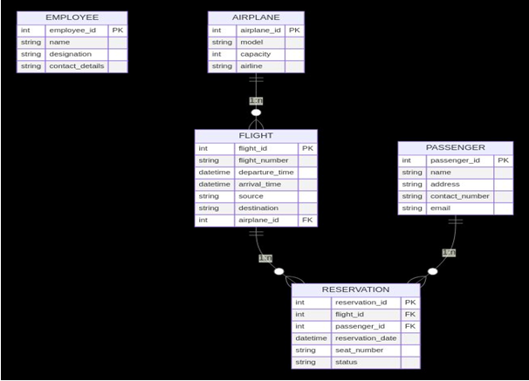

Appendices
Appendix A: Additional SQL Scripts and Sample Queries
1. Retrieve All Flights Between Two Cities
SELECT Flight_Number, Departure_Time, Arrival_Time, Source, Destination
FROM Flight
WHERE Source = 'Addis Ababa'
AND Destination = 'Nairobi';
Description: This query fetches all flights departing from Addis Ababa to Nairobi, displaying their flight numbers and schedules.
2. List of Passengers on a Specific Flight
SELECT P.Name, P.Contact_Number, R.Seat_Number
FROM Passenger P
JOIN Reservation R ON P.Passenger_ID = R.Passenger_ID
JOIN Flight F ON R.Flight_ID = F.Flight_ID
WHERE F.Flight_Number = 'ET302';
Description: This query provides the names, contact numbers, and seat assignments of passengers booked on flight ET302.
3. Flights Operated by a Specific Airplane Model
SELECT F.Flight_Number, F.Departure_Time, F.Arrival_Time
FROM Flight F
JOIN Airplane A ON F.Airplane_ID = A.Airplane_ID
WHERE A.Model = 'Boeing 737';
Description: This query lists all flights operated by airplanes of the model 'Boeing 737', along with their departure and arrival times.
4. Employee Contact Information by Designation
SELECT Name, Contact_Details
FROM Employee
WHERE Designation = 'Pilot';
Description: This query retrieves the names and contact details of all employees designated as pilots.

BIBLIOGRAPHY
REFRENCE BOOKS
E. Balagurusamy , Object Oriented Programming with C++ , Tata McGraw-Hill Publishing house , Copyright 1998.
The ‘C’ Programming language by Kernighan & Ritchie, Prentice Hall Publishing house,
Copyright 1988.
Teach yourself C by Yashwant Kanetkar, BPb Publishing house edition-6th.
Software engineering , K.K. Aggrawal, new age international publisher.
WEB REFERENCES
www.cprogramming.com/tutorial.html
www.cplusplus.com/doc/tutorial/
www.coronadoenterprises.com/tutorials/cpp/index.html/

